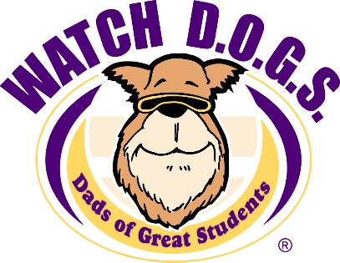
ALL ABOUT

What is WATCH D.O.G.S.?
WATCH D.O.G.S. (Dads Of Great Students) is an innovative father involvement, educational initiative of the National Center For Fathering. There are 2 primary goals of the WATCH D.O.G.S. program:
1) Provide positive male role models for students and demonstrate by their presence that education is important.
2) Provide an extra sets of eyes and ears to enhance school security and reduce bullying.

Who are WATCH D.O.G.S.?
WATCH D.O.G.S. are fathers, grandfathers, uncles, and other father-figures who volunteer for at least one day each year at Maple Hills. During the day, WATCH D.O.G.S. may work with students, play at recess, eat lunch with students, watch the school entrances and hallways, assist with traffic flow and any other assigned activities where they actively engage with not only their own students, but other students as well. On the day of their participation, WATCH D.O.G.S. are given a daily schedule of their involvement and they wear an official WATCH D.O.G.S. t-shirt identifying them as WATCH D.O.G.S..

Sign me up for WATCH D.O.G.S.!!!
If you are interested in being a hero to your kid, and joining this great program, please fill out the form below and return it via ‘kid mail.’ Please visit: https://www.isd411.org/get-involved/volunteer to complete the Volunteer Background check form, and once you’re cleared, we’ll send you a link to sign up on the WATCH D.O.G.S calendar. If you have any questions, please email us at: watchdogs@maplehillspta.com.

YES! Please sign me up to be a WATCH D.O.G.

First Name: _____________________________________________________
Last Name: _____________________________________________________
Email address: __________________________________________________
Phone: ______________________
Maple Hills Elementary PTA

